Town of Coalhurst
Pumpkin Recycling
Where? Miners Park (5700-2st) Beside the skating rink.
When? November 1-6, 2022
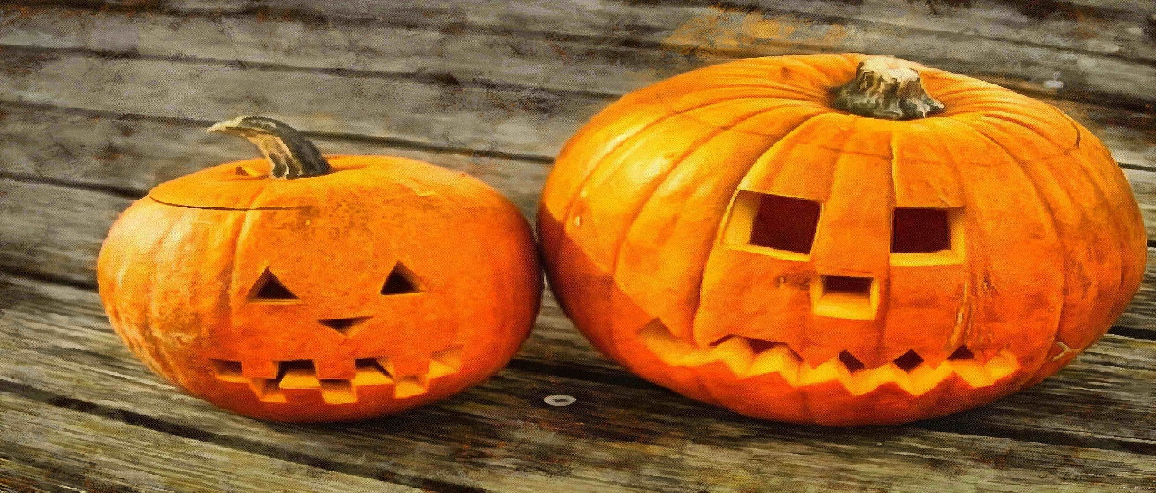

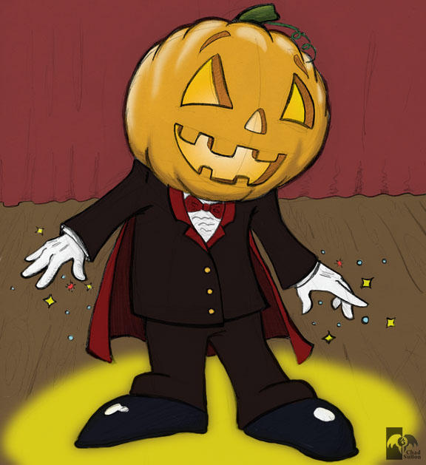
The bin is for pumpkins only. All other recyclables can be disposed of at our recycling depot on 7 street.

